

|  |
| --- |
| C.P.N.M. LAB REPORT |
|  |
| ASSIGNMENT 1  BCSE FIRST YEAR FIRST SEMESTER  Authored by: SOHAM CHOWDHURY |



**CPNM LAB ASSIGNMENT REPORT**

BCSE FIRST YEAR FIRST SEMESTER 2021-2022

NAME-SOHAM CHOWDHURY

DEPARTMENT-COMPUTER SCIENCE AND ENGINEERING

SECTION-A3.

ROLL NO-002110501145.

# ASSIGNMENT 1

1. write an algorithm to determine the maximum of three numbers. Also draw the corresponding flow chart.

Algorithm:

Step1: Start

Step2: enter three numbers from user and read as a, b, c

Step3: if (a>b && a>c) then print a is maximum among three numbers. else If(b>c && b>a) then print b is maximum among three numbers. else If(c>a && c>b) then print c is maximum among three numbers. Above three cases found if user input three diff numbers, if user input two same and one different number then here also another three cases found, they are : else If(a==b && a>c && b>c) then print a or b is maximum among the numbers and a number is repeated two times else If(b==c && b>a && c>a) then print b or c is maximum among the numbers and a number is repeated two times else If(c==a && c>b && a>b) then print a or b is maximum among the numbers and a number is repeated two times else If(c==a && c>b && a>b) then print a or b is maximum among the numbers and a number is repeated two times Also another case found if user entered three numbers then else print all three numbers are same

Step4: Stop

Flowchart:

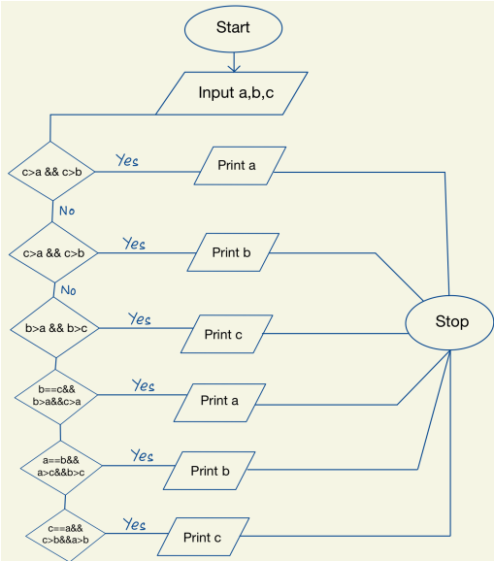

2)Write an algorithm to determine the sum of individual digits of a given integer. Also draw the corresponding flowchart.

Algorithm:

Step1: Start

Step2: assuming four integer numbers n, t, sum=0 & reminder

Step3: Entering value of integer number n from the user

Step4: t=n While t = 0 : reminder = t%10 sum = sum + reminder t = t/10

Step5: Print sum

Step6: Stop

Flowchart:

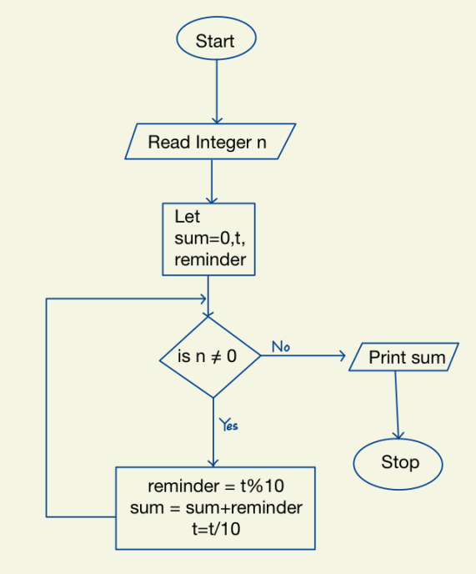

4) write an algorithm to determine whether a given number is prime or not . Also draw corresponding flowchart.

Algorithm:

Step1: Start

Step2: assuming three integer variable n, i, c defining one integer value c=0

Step3: Entering value of n by user

Step4: running a ‘for’ loop and also running another ‘if’ loop in for loop for(i=1;i<=n;++i){ If(n%i==0){ C++; } }

Step5: now if c=2 then n is prime number else n is not a prime number

Flowchart:

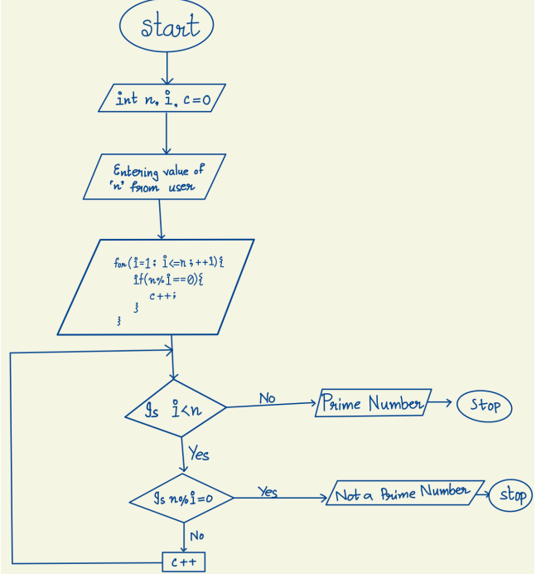

5) Write an algorithm to generate the first 100 prime number. Also draw the corresponding flowchart

Algorithm:

Step1: start

Step2: let num=2 and i=0

Step3: while i<100 do

div=2While div<num do If num%div==0 do num=num+1

break

else div = div + 1

if div = num do

print ‘num’

num=num+1

i=i+1

Step4: stop

Flowchart:

